Revised October 2011

West Suffolk House

By Roderic Bunn

Occupied in March 2009, the building was procured and jointly funded by two local authorities, Bury St Edmunds Borough Council and Suffolk County Council. The two authorities joined forces to rationalise a number of their older office buildings into a single, shared facility.
Between them, the two authorities had 13 strategic aims for the new building, with specific emphasis on organisational culture change, environmental sustainability, and accessibility for the public. The project was also the first phase of a programme to create a Public Services Village, where other public sector organisations, such as the police, the primary care trust and magistrates courts, could relocate.
The two councils have ended up with a largely open-plan building of 6430 m², with 11 m-deep floor plates encircling an open full-height lightwell. The ground floor of the lightwell is home to a large public cafe, with upper floors housing various meeting rooms, a conference hall and a Mayor's parlour. Reflecting the rise in home, mobile and flexible working, the councils have provided eight desks for every 10 employees. Break-out meeting areas and staff kitchens are adjacent to the lightwell on the upper floors.
The lightwell is topped by a mono-pitch roof, oriented to the west, with clerestory glazing at high level. The atrium roof is inclined against the prevailing winds to induce natural ventilation through the open plan offices and exhaust to the leeward side.

Site issues
The building's prominent location, on the corner of Western Way and Beetons Way in a regeneration area of Bury St Edmunds, gave the architects the opportunity to create a landmark building.
The building is oriented North-South, with the effect that the office floors receive direct sunlight from the East and West elevations. This had obvious implications for the control of solar gain and glare.
An environmental survey revealed that the site was contaminated from various wastes and materials and residues from fuelling and maintaining council vehicles.

Procurement
West Suffolk House started out on the right foot, but using a delivery team familiar to the client. Any benefits this gave were subsequently put under stress by a rushed design and build phase, not made any better by the liquidation of a major contractor to the project. All this then compressed the commissioning and handover phase.
Suffolk Council's existing contractual framework agreement was used to assemble the project team. The main contractor was Wates Construction, with Dodd Group as the M&E subcontractor. Design was procured from the Leicester office of multidisciplinary architectural and engineering consultancy Pick Everard. The appointment was less design and build and more a target cost contract, with the detailed design being done by Pick Everard.
While the framework had been in place for about two years, much of its work had been on building new schools, so an office building represented a learning curve for the project team. Many of the building's proposed features were also innovative and involved low carbon technologies.
The build programme was tight to meet the target occupation date of January 2009 as the Council's head of property services, Ivan Sams, recalled.
"We went wrong in trying to meet our target start date and get the contractor on site," said Sams. "The designers had difficulties keeping up to date with providing design information, and the process was very demanding and cost-driven."
"Perhaps variations also happened too quickly," reflected Sams. "The contractor was always requesting information and decisions, and sometimes it was a case of design information being generated and the design being built on the same day."
Sams reflected that the client initially didn't "get a total handle" on how much was being spent, nor the cost of the variations. As a consequence, the project underwent a value engineering exercise that reined in the growing costs.
The compressed build programme created other problems, not least of which was the lack of a commissioning plan for the building. Without a proper plan, and in the absence of a client representative with enough knowledge, the client body found itself relying heavily on the contractor, the m&e contractor and the consultant once they'd moved in.
At the time of writing, a year after completion, the m&e systems had not been accepted. "Fortunately the Framework team have been very attentive, and we've been getting good response over the last nine months," said Sams. "We hope to sign off the m&e systems in March 2011." Suffolk Council has engaged an engineer on an hourly basis to manage the building, provide expert advice and fine-tune the systems.
The build programme was compromised by the liquidation of the contractor appointed to provide the innovative Bubbledeck pre-cast structural slabs. Two thirds of the building had been constructed when the contractor went bust.
"Everyone worked well to find a solution," said Sams. "We managed our way around it, but it caused a month's delay to construction."
The target date slipped from January to March 2009, but full occupation was achieved in April 2009.

Architecture and engineering
In terms of its technical specification, the building's design presses many of the right buttons. It uses passive design to reduce the demand for mechanical heating and cooling. The thermal capacity of the exposed concrete construction has been boosted by renewable energy sources in the form of heat pumps supplying hot or cold water to pipes encased in the pre-cast slabs.
On debit side, it seems that the 11 m deep occupied zone may be asking too much of the natural ventilation strategy (and the facade design that supports it), to the point where the majority of occupants report very negative views of temperature and air quality. The complexities of the ventilation, heating and cooling strategies were also not matched by the quality of commissioning and finishing off.
West Suffolk House is largely of reinforced concrete, with brick and block cavity walls for the external envelope. A pressurisation test achieved an air leakage rate of 7 m³/h.m² at 50 Pa.
The building has been designed with a reinforced concrete super structure to provide a good thermal mass to help achieve good comfort conditions in the summer.
A U-value of 0.28 W/m²K was specified for the external walls, improving on the requirements of the prevailing Building Regulations. Solar performance glazing was specified for the East, South and West elevations, with a U-Value of 1.51 W/m²K. Low-e glass was used in north-facing elevations.
In a first for the UK, the internal floors are of a cast flat slab called Bubbledeck. This Danish system, fabricated in the UK under licence, is essentially formed of 200 mm diameter plastics bubbles laid in a mesh of steel reinforcement to form a cage, the combination of which is then cast in concrete. The plastics bubbles reduce weight, enabling longer spans between columns. The thinner concrete endows the slab with a better thermal response. The suppliers quoted a cooling output of about 47 W/m² and a heating output of 34 W/m².
The open-plan offices are naturally ventilated via Windowmaster motorised windows (automated, with local occupant override). Extract is via high-level clerestory windows. The ground floor is served by a mechanical displacement ventilation.
Natural ventilation is achieved by a mix of manually openable windows and motorised fanlights under the control of a Windowmaster system. The Windowmaster controls adjust window opening to meet an internal air temperature or air quality condition.
Occupiers can also override the automatic controls by using a local wall-mounted switch. During evenings and weekends the system has the capability of opening windows to provide night ventilation.
The system was commissioned by the Windowmaster controls specialist, who also provided end-user training. The system is not connected to the BMS, so the facilities team need to switch between the two controls systems.
A variable-air-volume system with comfort cooling serves the ground-floor offices and meeting rooms, and a conference facility on the first floor. This is under the control of occupancy sensors. Local ceiling ventilation units were also installed in small offices and meeting rooms. All mechanical ventilation systems incorporate heat recovery. The ground floor is served by mechanical displacement ventilation.
Following a successful grant application, St Edmundsbury Borough Council secured funds from the LCBP to install four, open-loop ground-source heat pumps (GSHP). Two heat pumps a configured for cooling and two for heating, giving the ability to generate 463 kW of heating and 430 of kW cooling simultaneously. The design seasonal co-efficient of performance (CoP) was calculated to be 4.
Heating and cooling pipework has been cast in the concrete Bubbledeck slabs to turn them into an active radiant heat and cooling system. The radiant heating supplements the perimeter heating system in the naturally ventilated open-plan spaces during peak design periods. In summer, the GSHP circulates chilled water through the embedded pipes, and also through cooling coils in the air handling units.
Chilled water is run through the pipework once the contribution of the thermal mass has been exceeded in summer, and once the limits reached with what is possible with night purging. A BACnet BMS control system interfaces with the Windowmaster system to ventilate the office before the slab cooling system is used. . This is set to operate when internal temperature exceeds a threshold. Condensation is prevented by temperature sensors embedded in the slab.
The heat pumps also supply heat to a conventional lthw underfloor system in the cafe, with top-up by conventional gas boilers to meet peak demand.
Two roof-mounted solar thermal systems pre-heat the cold water supply. This is supplemented in storage calorifiers by gas boilers with electric immersion heaters as back-up. The solar thermal system, which tracks the sun, was designed to generate 20 per cent of the building's annual hot water needs.
Lighting systems confirm to best practice, with daylit-dimming T5 fluorescents in the open plan areas and passive-infrared detection on low energy light sources in the meeting rooms and toilet areas.

Initial building performance
Despite all the problems in the build phase, the client is generally happy with the building. "It works fantastically well in the summer, and overall it performs brilliantly," said the Council's head of property services, Ivan Sams.
In maintenance and management terms, the occupiers didn't anticipate the complexities of running a building with such a high level of innovation. "Had we known the issues, we would have resourced ourselves differently," he added
In the first winter of occupation West Suffolk House overheated. The cause was found to be a wrongly located thermocouple for the cafe underfloor heating. The sensor had been placed outside some changing rooms rather than in the lightwell area, with the result that the open plan areas overheated. The sensor will be relocated by the controls supplier.
Initially, the variable-air-volume (VAV) ventilation did not cope with the cooling loads in training rooms and the revenue office. Additional floor grilles have been added to the training room. An additional cooling system is being considered for the increased occupation density in the revenue office.
The radiator control valve settings were also changed in the meeting rooms because of complaints the rooms were not warm enough in the winter. It was later established that two heat pumps did not operate during the first few months, resulting in a heating system that was failing to meet demand.
A substantial amount of heating has been provided by the gas boilers rather than ground-source heat pumps (GSHP). Leaks in the GSHP also occurred as a result of blocked strainers. The system was cleaned and filters installed to reduce the risk associated with dirt residue.
The Windowmaster motorised windows were said by Sams to be good. "Some tweaking has been required, such as for the winter and summer crossover settings," he said. "We had issues when windows were staying open, or not shutting completely, and some people were too cold."
During design, a value engineering exercise lead to the removal of the brise soleil along the east and west elevations in favour of high performance glazing and solar control blinds. According to Ivan Sams, the blinds were chosen primarily to complement the internal colour scheme, and the fabric wasn't good enough to cut out glare. The property services team has been forced to replace the blinds.
Since occupation there have been several complications with the building management system (BMS), largely due to the quality of commissioning prior to handover. The complex GSHP heating and cooling system has not worked well with the other energy-saving measures, such as the night ventilation, ground cooling and solar thermal systems. These issues are being addressed and improved though seasonal commissioning.
The lighting controls have not operated as intended, and commissioning has continued after handover. A ‘last person out’ master switch has been installed to switch off all fittings before the building is shut down at night.
Radiator control valve settings were changed in the meeting rooms as the rooms were not warm enough in the winter. It was later established that two heat pumps did not operate during the first few months resulting in a system the failed to match demand. A substantial amount of heating was therefore provided by the gas boilers rather than the heat pumps.
The property services team were surprised to find that the main water usage was far higher than expected. Investigation found that the rainwater recovery tank was being kept full by the mains, and rainwater was being discharged to waste.

Energy consumption
The initial performance of West Suffolk House has been disappointing. Some of the underperformance is a consequence of inadequate commissioning and finishing off at occupation, amplified by the usual defects and snags typical of new build projects, but some of the issues are more fundamental.
Energy consumption is far too high for a building of this technical specification. The problems are less in the technology, and more in the way the systems and their controls have been set up and commissioned. The energy metering does not deliver enough information, nor is it accurate. For example, an inability to control the heat pumps properly has led to simultaneous heating and cooling.
Arup was commissioned by the Carbon Trust to monitor West Suffolk House for 12 months after completion. This included analysis of its energy consumption and carbon dioxide emissions. The results were compared to the design intention and the relevant typical and good practice benchmarks.
The initial overall gas and electricity consumption is shown in figure 1.
Total energy use at West Suffolk (including electricity for office equipment, IT servers and catering) is 201 kWh/m² per annum. This compares with the design prediction of 66.2 kWh/m² per annum (including 31.9 kWh/m² per annum for unregulated loads), and the good practice hybrid benchmark in ECON 19 of 103 kWh/m² per annum. The CIBSE TM46 median benchmark is 215 kWh/m² per annum.
Despite a design calculation for gas consumption being 13.9 kWh/m² per annum, gas was used extensively in winter when the heat pumps were meant to be the main source of heat. Given that gas consumption was 48.3 kWh/m² per annum, the boilers must be picking up at least 50 per cent of the load. To put this into a broader context, the ECON 19 good practice benchmark is 81 kWh/m².
The initial absence of metering on the geothermal heat pumps (and the non-operation of two of the heat pumps for a period), meant that it was not possible to apportion accurate gas consumption to the top-up heating or to the domestic hot water system.
It is important to stress that the energy consumption in the first 12 months should not be taken as representative of the building's long-term performance. There are many variables: outstanding defects, delayed commissioning, phased occupation, and fine-tuning of systems to suit occupants' needs, and seasonal re-commissioning can all conspire to distort initial energy performance. The energy meters themselves may not be reporting energy use accurately. For these reasons, readers should not be too harsh in their judgement.
There were also difficulties in measuring energy use in the first 12 months. Although the sub-metering may comply with the Building Regulations, it has not proved effective. Instead of being installed on the main LV switchboard, sub-meters have been installed in the electrical riser cupboards on each floor at foot level, where it is extremely difficult to read them. These meters do not separate lighting from small power.
The energy meters on the heat pumps were not delivering readings for the first three months of the study period, which has made it difficult to apportion annual energy use with any accuracy. It was also difficult to measure the effectiveness of the direct cooling system, or to identify the balance of energy use between the gas boilers and the solar panels. The contribution of the heat pumps for space heating is estimated at 7.1 kWh/m² per annum. With the lack of energy meters in the heating or cooling circuits it is not possible to establish the CoP of the GSHP system. Since the system also incorporates a direct ground cooling circuit, overall a high seasonal CoP (greater than 5) would be expected.
Attempts to use the BMS to record energy use have been hampered by discrepancies between BMS meter readings and manual meter readings. To make matters worse, only some of the meters are linked to the BMS for automatic data collection. The property services department is taking manual meter readings, but the numbers do not add up.
For the 12 months to November 2010 (occupation March 2009), West Suffolk House consumed 152.5 kWh/m² of electricity. This is nearly three times the design prediction of 61.1 kWh/m² per annum (with no heating contribution from gas).
The performance of West Suffolk House has been compared with a modified Energy Consumption 19 benchmark. As West Suffolk House is a mixture of naturally ventilated open-plan space and air-conditioned enclosed space, an electricity benchmark of 108 kWh/m² per annum was created that combined the values for a Type 2 and Type 3 office building (Figure 1). The median benchmark in CIBSE TM46 Energy Benchmarks is 95 kWh/m² per annum.
When heat demand is plotted against degree-days, evidence emerges of poor control of the heating system. In summer, considering that the estimated hot water demand is 8700 kWh per month (based on 15 litres/person per day), there may be high losses from distribution and controls.
Extrapolating from nine months heat pump data, Arup has calculated a cooling demand during spring and winter rather than the summer. As consumption seems to follow a heating system profile, Arup suspects that the labels on the heating-only and cooling-only heat pumps have been fitted the wrong way round. If the label references are indeed wrong, and the energy profiles are switched, there is still a problem: a cooling demand all year, with simultaneous heating and cooling in winter.
If true, passive measures such as night ventilation and thermal mass may not as effective as initially thought. Either that, or there are deficiencies in the controls system.
Lighting and small power is not metered separately. The designers calculated a joint consumption of 48 kWh/m² per annum (lighting at 16 kWh/m² per annum, and office equipment at 32 kWh/m² per annum) against an ECON 19 good practice hybrid benchmark of 46 kWh/m² per annum (lighting 22 kWh/m² per annum, power 20 kWh/m² per annum, miscellaneous 4 kWh/m² per annum).
Actual consumption for lighting and small power is 55.1 kWh/m² per annum. The energy assessment led the researchers to judge that the lighting accounts for slightly less than two thirds of the consumption, at 32.3 kWh/m² per annum. This is higher than the design estimate.
Power supplied for ICT, catering equipment and fans, pumps and controls comes in at 41.3 kWh/m² per annum compared with the good practice hybrid benchmark in ECON 19 of 23 kWh/m² per annum. The ICT load contributes about 50 per cent of the total consumption. Although measures to increase room temperature and turn off idle office equipment have been implemented, there hasn’t been a significant change in consumption.
Consumption of pumps, fans and controls has come in at 11.9 kWh/m² per annum, against a good practice value of 6 kWh/m² per annum. Arup suspects that the high consumption could be due to the high number of pumps serving the ground-source heat pump system.
Out-of-hours consumption is high: between 07.00 – 18.00 h at weekends the consumption is double the 30 kW base load. The peak 19 kW ICT load suggests that other equipment is consuming power.
Hot water consumption is estimated at 2.9 kWh/m² per annum. The yield from the solar thermal panels is estimated at 1.6 kWh/m² per annum, or 55 per cent of hot water demand (25 per cent was estimated by the solar panel manufacturer at the design stage). The design target was 8.7 kWh/m² per annum, compared with the guidance in CIBSE Guide G of 16.3 kWh/m² per annum.
Actual hot water consumption is lower than the benchmarks, possibly because demand associated with catering (such as dishwashers) has been excluded. In summer, the solar tracker system generates more energy than the demand.

Carbon dioxide emissions
The energy data extrapolates to the building's carbon dioxide emissions (Figures 2 and 5). The energy consumption of West Suffolk House equates to actual carbon dioxide emissions of 88.4 kgCO₂/m² per annum, nearly three times the design estimate of 31.4 kgCO2/m² per annum (figure 2). The ECON 19 good practice (hybrid) benchmark is 51.8 kgCO₂/m² per annum. The median value in CIBSE TM46 is 75.1 kgCO₂/m² per annum.
One of the glaring findings from the analysis is the huge disparity between actual emissions and the emissions predicted by the simulation model (Figure 3). The difference between prediction and reality is so great, that one might conclude that simulation models are wholly inadequate for setting realistic ambitions for energy use and carbon dioxide emissions.
The simulation model is not required to take into account all loads, actual installed equipment, or hours of operation. The EPC thus generated creates an illusion for both client and design team that is shattered by actual performance data. Without a regulatory (or contract) requirement on the design team to revise the energy use estimates as the project progressed, as more information became known about actual equipment loads and run times, the actual energy use came as a rude shock.
The building's asset rating, estimated at design, was in band A. The operational energy rating of West Suffolk House is 106, placing it in band E. Note that typical buildings score 100.
As with the energy figures, the carbon dioxide emissions from the building's first year of operation should not be considered indicative of the building's long-term performance. However, at this stage, West Suffolk House is not operating as a low carbon building. Had the building had been fully commissioned and set to operate as designed, then the overall performance may have been closer to the design. The performance of West Suffolk House should improve as its systems are fully commissioned and fine-tuned.
Figure 3 shows how initial carbon dioxide emissions at West Suffolk House compare to requirements of the 2002 and 2006 Building Regulations, the calculations of the design team, and predicted performance once emissions reductions from renewable energy sources and additional passive energy measures are taken into account.

Occupant survey results
West Suffolk House is viewed by its occupants as being an uncomfortable building. There is strong evidence, from workers on all open plan office floors, that the ventilation and comfort systems are ineffective. On one level this is a surprise, as the building appears to be light and airy, if a little soulless in terms of colour and visual stimulation. Appearances can be deceptive however.
A Building Use Studies (BUS) occupant survey was carried out in February 2011. The survey was carried out by consultant Arup, under its Arup Appraise service. The survey was statistically valid, with 241 survey forms being returned.
The survey was carried out nearly two years after occupation, which is a good point at which to poll occupants for their views. (However, given that the building's m&e systems have yet to be signed off as complete, the survey results may not be wholly representative of long-term performance.)
Figure 4 shows the building's performance against the 12 BUS summary comfort variables.
In terms of overall satisfaction, West Suffolk House has scored poorly. Internal temperature, air quality, noise, health and overall comfort all received low scores compared with the rolling BUS benchmark dataset of 80 comparable buildings. Satisfaction with lighting, the degree to which needs were met, and the design of the building were all close to the benchmark average.
The only score above benchmark was that for the building's image to visitors. This is not uncommon with new buildings with a strong architectural aesthetic – occupants can be aware that a building has a good appearance, even though it may not be perceived to be comfortable and productive.
The results may be surprising given the attention to the building's ventilation and lighting design, the active involvement of the occupants in the briefing process, and the evidently caring and attentive facilities management. However, the anecdotal responses are illuminating.
The building is perceived to be an unhealthy work environment by 66 per cent of the occupants. Many complain of fatigue, sleepiness, headaches, and greater incidence of colds and flu viruses.
A majority of occupants complain of poor ventilation, workplaces that are either too stuffy or too draughty, and noise breakout from the ground floor atrium and cafe. "Too hot, stuffy and noisy" was a common refrain. These comfort problems are perceived to reduce productivity.
Two quotes from occupants serve to sum up the occupants' view of the building. One person said: "It is very nice looking, however it is far too bright and the noise is terrible...from all over the building. The temperature is erratic, either far too hot or far too cold." Another occupant said: "[I] ask for windows to be opened, but by the time we feel any cool fresh air, people sitting by the window are getting cold and close the window." Feedback such as this suggests that it is asking a lot of windows to ventilate evenly and effectively 11 metres into the space, when those nearest the windows will often dictate when they are open or closed.
Complaints about poor ventilation and glare may reflect early problems with the motorised windows and inadequate glare control blinds. The premises team found that windows were getting out of synchronisation, with some remaining open while others were shut. The maintenance engineer has been correcting the system manually by switching between the two settings using the local manual override switch. The original blinds have been replaced.
Overall, the occupant survey results are very poor. They also give cause for concern, considering the time and effort at was invested in the building's technical design. The scores are also surprising given that the building achieved a BREEAM 'Excellent' rating.

What this tells us
Considering its high carbon dioxide emissions, it is difficult to suggest that West Suffolk House is performing as a low carbon building. The difference in performance could partly be explained by the complexity of the HVAC system and controls. If the building had been fully commissioned and set to operate as designed, then the building's initial performance may have been closer to the modelled prediction.
If the simultaneous heating and cooling in winter could be prevented, the weekend consumption reduced, and better control achieved over the lighting, Arup estimates that energy use could be cut by 77 000 kWh, equivalent to a six per cent of the overall consumption (and a seven per cent reduction in carbon dioxide emissions).
The difficulty in attributing consumption to end-use clearly illustrates the need for separate energy metering, particularly for systems like electric heat pumps, which share load with gas-fired boilers and solar thermal panels. Without separate meeting, the contribution by each system cannot be measured, and the carbon dioxide emissions cannot be calculated accurately.
Key activities like commissioning automatic controls need to be completed and tested, even after the building has been occupied. This approach requires a change in contractual agreements and expectations prior to project handover.
West Suffolk House demonstrates the need for better attention over where meters are placed. They also need to be fully commissioned, and reconciled with the main incoming meters and any monitoring software run on the building management system.
The occupant survey demonstrates that a large gap still exists between the objectives of clients and their design teams when it comes to defining the specification for a successful, comfortable and productive open-plan low energy office. The emphasis on spatial flexibility, convenience, and uniformity are often driven by institutional norms, and comfort outcomes based on the predictions of simulation models.
For design ambitions and technical predictions to perform in reality, there possibly needs to be a greater focus on operational outcomes. There also needs to be a robust way of expressing those operational outcomes, so that things that are not considered important to designers and contractors are able to rise further up the project team's list of priorities.
The article is based on building analysis carried out by Mark Katatumba of Arup, funded by the Carbon Trust.
Roderic Bunn is a principal consultant in building performance analysis at BSRIA Ltd working for the Carbon Trust on its Low Carbon Buildings Performance programme. He is also a lead Building Performance Evaluator for the Technology Strategy Board.
The research was carried out by the Carbon Trust within its four-year Low Carbon Buildings Performance programme (LCBP). The overall objectives of the LCBP were to demonstrate combinations of both energy efficiency and micro-generation/low and zero carbon energy technologies in a single development. The objective was to reduce carbon dioxide emissions, demonstrate emerging micro-generation/low and zero carbon energy technologies and measure their performance in use, and raise awareness of the business case for developing low carbon buildings.

Key lessons

Metering
The lack of sufficient metering on the heat pumps, ground cooling and hot water generation system has compromised control and energy efficiency. The sub-metering strategy needs to be considered early in the design, with input from the client’s team to ensure that all appropriate systems are sufficiently metered to facilitate good monitoring and control. Solar thermal and domestic hot water systems should be metered separately, as should the energy inputs and outputs from bivalent systems.

Commissioning
Seasonal commissioning is recommended for automatic controls and renewable technologies, such as ground-source heat pumps, to ensure that systems operate at optimum condition even after the building has been handed over. Post-occupancy monitoring ought to be included as a separate client appointment, and preferably provided by an independent consultant.

Lighting controls
Electric lighting often defaults to on, even after people have left the building. Some daylight dimming fittings at West Suffolk House have remained on during the day. Lighting controls should be commissioned and tested against design requirements prior to handover. Often, manufacturer settings are maintained which do not necessarily suit the area served. A user guide should be prepared to advise end-users of the various forms of lighting control.

Aftercare
Clients should appoint energy consultants to help ensure the building is set to operate effectively during the initial stages of occupancy. The facilities manager should then continue monitoring the performance throughout the life of the building.

System complexity
Interdependent heating and cooling systems can get very complicated when different types of sources, such as gas boilers, ground-source heat-pumps and solar thermal, are linked in a system. Systems should be designed and controlled to operate in a clear and simple manner that the installers, commissioning engineers and the client's facilities team are able to manage and maintain. The integration of different systems needs to be properly understood and demonstrated.

Figure 1: Energy performance of West Suffolk House compared with design modelling and the relevant (hybrid) benchmark from Energy Consumption Guide 19 (ECON 19). The carbon factors used to calculate emissions were 0.198 for fossil fuel (gas) and 0.529 for electricity.

Figure 3: The Carbon Trust's Low Carbon Building Performance (LCBP) research project concluded in March 2011. 23 LCBP projects were awarded DECC grant for renewables and Carbon Trust mentoring. 18 projects completed and monitored. All buildings aimed to be low carbon (>30% below Part L 2006)
The graph above is a typical outturn of many of the buildings studied. Initial carbon dioxide emissions at West Suffolk House are five times higher than the design prediction, and two times worse than the requirements of the 2002 Building Regulations. Note that the yellow bar represents fabric and efficiency improvements required by the 2006 Building Regulations over that of the 2002 Building Regulations. This forms the Target Energy Rating (TER). The BER excludes all small power consumption so that it is comparable to the Building Regulations. The percentage emissions reduction commitment (PERC) is shown as a combination of the regulatory requirement for up to 10 per cent renewables, plus additional investment in fabric or systems efficiency (such as extra insulation) voluntarily funded by St Edmundsbury Borough Council.

Picture caption for heat pumps: With the lack of energy meters in the heating or cooling circuits it is not possible to establish the co-efficiency of performance of the ground-source heat pumps. As the ground-source system is an open-circuit, a high seasonal CoP (greater than 5) would be expected.

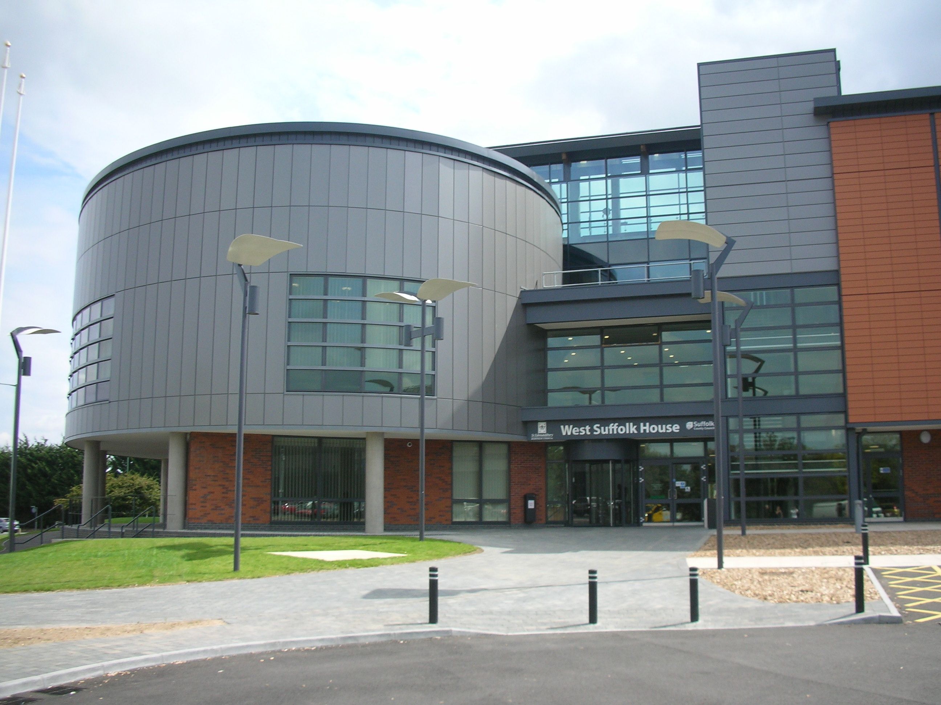
Caption 1: The ground floor and protruding oval drum contain the open plan public lobby, which provides access to ground floor public meeting and conference rooms.

Caption: The ground floor layout. A 10 m by 25 m full-height lightwell spans across 70 per cent of the core, open from the ground through to level 3. Levels 1 and 2 contain open-plan offices on both sides of the atrium. The floor plates are 14 m deep, contained on a 7 m by 11 m column grid. The drum contains a central conference area and council chamber on level 1. the ground floor which contains public access areas such as reception, meeting and conference rooms, café, ICT rooms, reprographics, toilets and changing facilities. An open plan office and facilities department are also located on the ground floor.

Caption: West Suffolk House in elevation. The Bubbledeck floor slabs enable long, single structural spans to be achieved, which accounts for the 11 m-deep floor plates. [Simplify the figure].

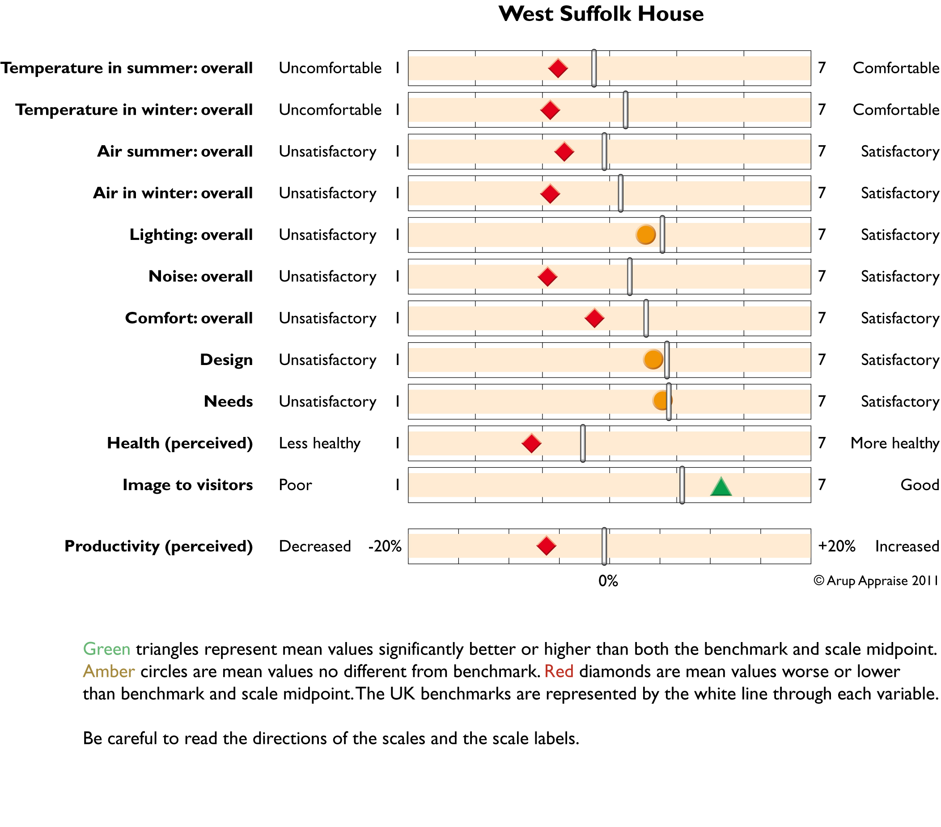

Figure 4: The results of the occupancy satisfaction survey carried out in February 2011. The building has 541 workstations, and 241 survey forms were returned. The benchmark database contains 80 comparable office buildings.

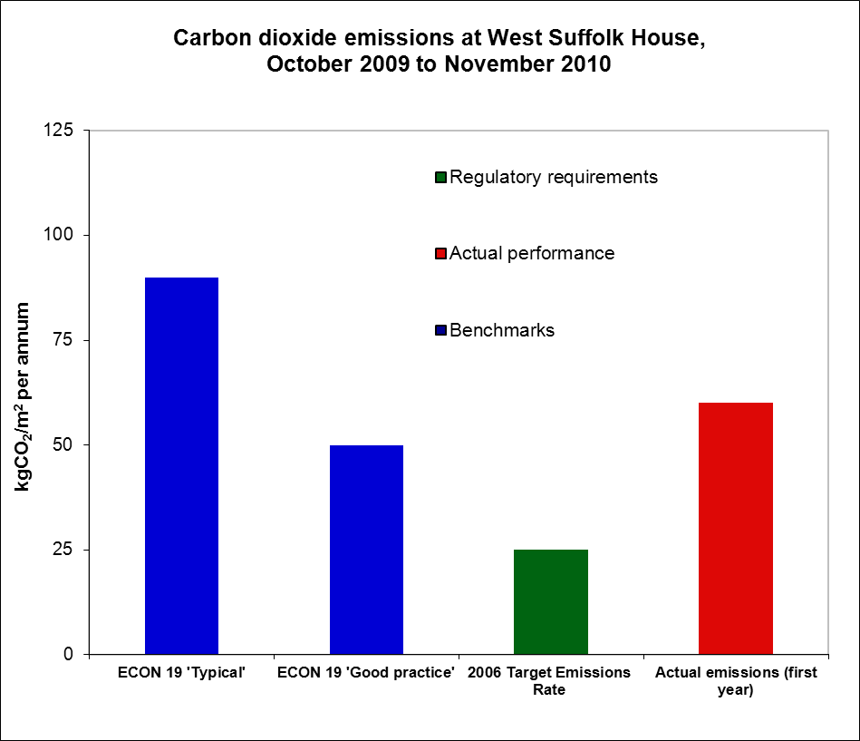

Figure 5: Carbon dioxide emissions from West Suffolk House compared with design modelling and the relevant (hybrid) benchmark from Energy Consumption Guide 19 (ECON 19). The carbon factors used to calculate emissions were 0.198 for fossil fuel (gas) and 0.529 for electricity. Data is derived from Figure 1.

