August 2011 revisions

Canolfan Rheidol

By Roderic Bunn

Take a hectare rural site in Aberystwyth, West Wales. Create a master plan involving new offices for Ceredigion County Council and the Welsh Government (WG). Add a leisure centre, two swimming pools and three schools, and you have the ingredients for a large district heating and cooling scheme, all powered by renewable sources of energy.
For renewable source, read biomass. Commercial forestry in Wales harvests around 770,000 tonnes of sustainable timber each year. Of this, around 230,000 tons ends up as residue, half of which is high quality woodchip. Of the 115,000 tonnes available, the project at Aberystwyth would need just 4,000 tonnes of wood chip per year.
Security of energy supplies doesn't get more certain than that. The question is: now that key buildings on the site have been occupied and the biomass-powered district system is up and running, how well is it all working? Has the Ceredigion County Council hit its energy and carbon dioxide targets, and are the occupants comfortable and more productive?
The Carbon Trust through the Department of Energy and Climate Change's Low Carbon Building Performance programme has provided mentoring and monitoring support to Ceredigion County Council for the design and delivery of its new office building, now called Canolfan Rheidol. The support ran from the detailed design stage through construction and into post-occupancy monitoring. Every stage of the design and installation has been assessed, and the initial performance measured by the monitoring of energy consumption and occupant satisfaction.

Procurement
The brownfield site in the centre of Aberystwyth was divided into three plots. Two plots were allotted to offices for Ceredigion County Council and the Welsh Government. The third plot is still to be developed. The site lies between railway lines to the north and a busy road to the south, which meant that extra care was needed for natural ventilation to work.
The buildings were procured by a design and build target-price contract. Carillion was initially appointed as the main contractor, with Powell Dobson as architect and Hoare Lea as the consulting engineer.
The cost of the Canolfan Rheidol building was set around £12.4 million. This was a target price rather than a fixed-price contract, which meant the Council and Carillion would share the benefits of any cost savings or, alternatively, the cost of any over-run.
Carillion returned an initial cost of around £20 million for Canolfan Rheidol, significantly over the Council's budget. It proved impossible for the two parties to agree a price, so the Council bought the design from Carillion and went to Willmott Dixon (the runner up in the competition). Willmott Dixon instigated a value engineering exercise that reduced costs substantially while retaining the key elements of the low carbon design.
The main reason for the difference in cost is believed to be due to the differing approach to sub-contractors used by the two main contractors. Carillion work with larger sub-contractors under framework contracts, whereas Willmott Dixon use smaller and more local sub-contractors and were perhaps better placed to negotiate cost reductions. Some changes were also made to the structure and some design elements.
A district heating scheme, fuel store and boiler house were procured separately. The Council acted as architects and engineers while Atkins provided consultancy on the design of the district heating network.
The budget for Phase 1 of the network was £1.8 million. Around £700,000 of this covers main plant, with a further £500,000 for district heat mains. (Almost half of the cost of the heat mains was associated with crossing the railway line that separated the energy centre from the office buildings.)
Construction of Canolfan Rheidol began in July 2007, with practical completion on 9 July 2009. Occupation began from 20 September 2009. Useful data collection by the Carbon Trust started in October 2009.

Environmental design
The output specification for Canolfan Rheidol (prepared by the Council) included a specific requirement for annual carbon dioxide emissions to be less than 50 kgCO₂/m², and for the environmental design to achieve BREEAM Excellent. Although the design team set out to make the fabric insulation and airtightness of Canolfan Rheidol about 20 per cent better than the requirements in Part L2A. In the event, insulation was around the statutory requirement and the air pressure test result was 4.81 m³ (h.m²) at 50 Pa.
The 7200m² (GIA) building is of steel frame with pre-cast concrete floors. The majority of the external walls are curtain walling with some brick and block construction.
Passive solar architecture led to a commendably low calculated heat demand of 29 kWh/m² per annum, compared with the good practice Type 2 office benchmark of 79 kWh/m² per annum in Energy Consumption Guide 19 (ECON 19). High performance glazing and a mix of external horizontal and vertical shading is designed to cope with a range of sun angles throughout the year. This allowed a high level of glazing and good daylight penetration without problems with glare.
The environmental design was heavily influenced by the Wessex Water headquarters building in Bath. Canolfan Rheidol's floor slabs were originally to be coffered, just like the Wessex building, but cost reductions saw these replaced by pre-cast, flat hollowcore slabs. The slabs are left exposed to provide some passive thermal conditioning to occupied spaces.
The ventilation and cooling started out with natural ventilation backed up by mechanical displacement ventilation in some areas – a mixed-mode approach. The maximum allowable indoor temperature was set at 28°C, with an allowance of less than one per cent of occupied hours above 25°C. Hoare Lea conducted extensive computational fluid modelling to establish air flows and likely indoor temperatures under all operating conditions.
The displacement ventilation with mechanical cooling serves most of the ground floor (where more cellular office space is provided), plus areas on the upper floors where stack ventilation was not possible.
The upper floors of Canolfan Rheidol were to be largely naturally ventilated, with the facades designed to allow opening windows, inboard of an external glazed acoustic screen. The high-level opening windows were designed to encourage air to flow across the building, but mostly the natural ventilation air paths rely on the stack effect through the atrium, induced by raised rooflights with motorised openings on the north and south sides.
A site visit to Wessex Water revealed that substantial effort and regular visits from BMS engineers was needed to control the natural ventilation system effectively. The Wessex Water building also has back-up cooling to ensure continued comfort should the natural ventilation system be ineffective.
This, and other concerns, led to a revision of Canolfan Rheidol's ventilation design. Simulation modelling by Hoare Lea led the client to extend displacement ventilation throughout
areas that were previously naturally ventilated. Cost savings were made to keep the alterations cost-neutral, such as the omission of some chilled beams in the areas of the building that were originally intended to be mechanically cooled.
Even though the building became technically mixed-mode, the environmental strategy for the building was intended to maximise the times that the building can rely on the openable ground-floor windows and stack ventilation. The mechanical cooling for upper floors would only be used in the event of poor performance of the natural ventilation design or extended spells of exceptionally hot weather.
The combination of mechanical ventilation and openable windows may theoretically increase energy consumption, but the client believed that providing natural ventilation was important for achieving occupant satisfaction.
Conventional mechanical ventilation is used elsewhere, such as in the kitchen and restaurant areas. Close-control cooling is provided for server rooms, while fan-coil units are used in spaces of high gains (such as the IT workshop).
The heating system uses variable temperature control zones for the atrium and north and south sides of the building. Constant temperature circuits serve the air-handling units and the calorifiers, and the heater batteries for the kitchen and restaurant.
Lighting generally uses T5 and compact fluorescent lamps, with a target load of 2.2 W/m² per 100 lux in open-plan areas. Perimeter lighting on the atrium side of floor plates and on external walls has on-off control by photosensors (no dimming). Presence detection is also included for individual bays of the open plan areas, in open-plan circulation areas, and for toilets. The meeting rooms include some LED lighting.

Renewable energy systems
A variety of renewable energy systems were considered, and this was pared down to biomass-fuelled heating, some solar thermal arrays, and a micro-wind turbine. The cost of these elements came to around £780 000.
The biomass system was originally sized to meet the peak thermal load of the Canolfan Rheidol offices and the adjacent offices for the Welsh Government. The single boiler is a Binder unit with a nominal rating of 1.2-16.5 MW. It has currently been set-up to operate at 1.2 MW. The output is designed to be increased through re-commissioning.
The biomass boiler has a gas burner for ignition and a 1.2 MW back-up condensing boiler. There are no boilers in Canolfan Rheidol or the WG building.
The biomass boiler was phase 1 of a wider scheme to connect other local loads, such as a leisure centre and three local schools. These subsequent phases are on-hold due to lack of funds. The client has stated that the development of the district-heating network will be dependent on the financial support from government grants and schemes like the Renewable Heat Incentive.
If the schemes go ahead, the biomass heating system will serve buildings whose heating systems are estimated to emit 540 tonnes of carbon dioxide annually. Arguably the other buildings should have been connected first because of their more consistent loads, but the Canolfan Rheidol and W G buildings provided the right catalyst for the district heating scheme. The client had to start somewhere.
Two 11 m² solar thermal arrays supply a 1000 litre pre-heat cylinder for Canolfan Rheidol's hot water services. The solar thermal is expected to meet around 40 per cent of the building’s hot water needs.
The 6 kW micro-wind turbine was installed in Canolfan Rheidol's north car park. It cost around £60,000 and was originally estimated by Hoare Lea to generate around 10 MWh per annum, equivalent to a carbon dioxide saving of around 4.5 tonnes each year. `
Canolfan Rheidol's cooling system is based on two duty and standby Ammonia chillers, of 185 kW and 110 kW respectively. The custom-built chillers were chosen primarily to gain credits in BREEAM. The 25 per cent improvement in performance over conventional chillers raised costs by 50 percent, although payback was calculated to be less than five years.

Initial building performance
A key aspect of the commissioning and handover process and the bedding-in period was the relatively low number of defects on the project. The Council’s retained controls specialist was involved throughout the project and continued to visit site regularly after handover. This ongoing relationship has helped to fine-tune the building and is a significant factor in its good performance.
Despite some initial issues, the building has had few major problems since occupation. The client has reacted philosophically to issues that have arisen, and has accepted that the first year of occupation will involve a lot of bedding-in.
Energy metering has caused problems. Canolfan Rheidol is comprehensively metered, with sub-metering for all major energy using plant as well as separate metering of lighting and small power electricity use. In addition to the requirements of BREEAM, Ceredigion supported detailed monitoring of particular systems, and ensured that the BEMS and monitoring and targeting systems could measure the performance of natural ventilation and other systems.
The first problem was the lack of information on what each meter measures. The data gathered didn't help the client understand what needed to be fixed or improved. Understanding could be gained by studying the electrical schematics, the distribution board schedules and the as-built drawings, but it's unlikely that anyone would want to go that far.
Labelling of metering was also very poor. The extent of the systems monitored by each meter was not clear, and the labelling notation is unhelpful in establishing metered areas and systems. This meant the client was initially unaware of most of the sub- meters. When the BMS was interrogated and some sub-meters were found, the client said that they had never seen them before, which suggests a lack sufficient training during handover. Discussions with the controls specialist indicate that there may be more metering points installed than are recorded.
The effectiveness of the metering varies depending on the energy source. Gas metering is only effective in terms of overall consumption. Only a single gas meter oversees the consumption of gas by the ignition burner of the biomass boiler (sized to deliver the full 1.2 MW building load), and the gas back-up boiler. This means there is no way of knowing the split between gas used for ignition and gas used by the stand-by boiler.
The client believes that the gas burner is working to maintain the internal temperature of the biomass boiler when there is a problem with the biomass fuel system, and the stand-by gas boiler cannot be used. Discussions with Wood Energy suggest this is unlikely, but they state that the ignition burner may fire if the boiler is trying to maintain temperature at time of low load.
Heat is metered as it enters Canolfan Rheidol (and the adjacent WAG building) from the district heating network. This is useful in determining overall heat demand. However, only a single heat meter is provided to the output side of the biomass boiler. This meter does not capture heat input from the standby boiler. It is therefore not possible to establish accurately the heat losses from the distribution system, as the amount of heat being input to the system isn't being measured.
The heating system is generally very efficient. The only concerns over the system are that it sometimes needs to be kept live for very minor heat loads. A particularly bad example of this is that the Canolfan Rheidol's ICT suite has close-control cooling. At any time the cooling system may call for heat following dehumidification. However, there is no clear signal from the system as to whether it has a demand for heat.
Consequently, the pumps serving the constant temperature zone run continually as do the building’s primary heating pumps. This also means the secondary pumps in the district heating system run to keep a system hot that will probably not need heat. The system is live for what is effectively a ghost heat-load.
Similar low loads for the building’s hot water system may occur in summer. This will have a similar effect on the circulation system.
Canolfan Rheidol's natural ventilation system appears to be operating well with no significant reported problems other than a control defect with some of the high-level atrium louvres. This has since been fixed.
The mechanical cooling requirement is noticeably higher in meeting rooms. This is borne out by anecdotal evidence that indicates that meeting rooms and some of the cellular offices on the top floor get too hot. Similar spaces on the ground floor appear to remain comfortable. The client believes this is due to two factors: insufficient manual opening windows to the rooms on the top floor and the better performance of the solar shading on the ground floor. There are also management issues relating to the switch over between the natural and mechanical ventilation systems.
The building is likely to be more energy efficient operating with the mechanical ventilation and heat recovery in cold weather, but this requires good management of the openable windows and trickle vents by the occupants and the facilities team. Similarly, if displacement ventilation is switched on to cool the upper floors in warm weather, there will be a need to close windows. The temperature that the switchover needs to occur was not defined at the time of occupancy, and is being determined through experience. More effort may be needed to ensure all users understand the need to close manual windows when external conditions dictate that mechanical ventilation would be more efficient.
In winter months, the client noted that increases in carbon dioxide would cause the automatic windows to open, adding to the heating load of the building and causing drafts which were uncomfortable for some occupants. The facilities team have been adjusting the response times of the windows to get more acceptable comfort conditions.
The specific fan powers of the various air-handling units have been obtained by analysing commissioning results. This gave an average 2.2 W/litre with clean filters, and around 2.4 W/litre with dirty filters. While disappointing for a low carbon building with displacement ventilation, it can partly be explained by the late requirement to extend the ventilation system (the volume of air being moved was increased, but space for air handling plant and ductwork stayed the same).
The office lighting has achieved 2.05 W/m² per 100 lux. While excellent, the average work-plane illuminance is 538 lux – way above the design target. This high lux level led to complaints from users and light levels were reduced. The knock-on effect is that some users have been given task lights.
The metered data from the BMS indicates a lighting efficiency of 2.8 kWh/m² per annum. This good level of energy use means carbon savings of around 66 tCO₂ per annum when compared with the Type 3 Good benchmark for lighting in Energy Consumption Guide 19 (ECON 19).
The BMS has operated well and provides a good level of control to the various systems of the building (such as the natural ventilation). However, it is much poorer at monitoring building performance.
The design intent was to have a full metering and monitoring BMS which could be used to identify issues with energy use and to optimise the building performance. This was not easily done with the BMS in its as-installed configuration.

Energy use
It is important to stress that energy consumption in the first 12 months operation cannot be taken as representative of the building's long-term performance. There are many variables: outstanding defects, delayed commissioning, system fine-tuning, and the need for seasonal re-commissioning can all conspire to distort initial energy performance. In particular the energy metering at Canolfan Rheidol is not working optimally. For these reasons, readers should not be too harsh in their judgement.
As a mixed-mode building, Canolfan Rheidol does not fit perfectly with any of the ECON 19 category benchmarks. The building has mechanical displacement ventilation throughout and also has a reasonable cooling demand, so the most appropriate ECON 19 energy benchmark is the Type 3 office building. The relevant energy benchmark in CIBSE TM46 is that for general offices.
Canolfan Rheidol's overall performance appears to be fairly good when compared against the ECON 19 benchmark, particularly considering the likely increase in use of IT resulting in greater demands for electricity for office equipment and cooling for computer rooms (Figure 1). Comparison against the more recent TM46 benchmark for overall energy consumption indicates that the building performs slightly worse in energy terms than might be anticipated for a contemporary office building of this nature.
Carbon Trust monitoring finished in 2010. More recently (April 2011) an official Display Energy Certificate (DEC) survey has been done, giving the building a C rating of 56.
Heat loss from the district heating system is significant. Monitored data indicates that the heating distribution system (a 280 m run from the biomass energy centre to Canolfan Rheidol) has a system loss of around 37 per cent during low loads in May to August, and 22 per cent loss during the peak heating season (November to February).
More recently, further investigation by the client has revealed a significant pipework leak requiring the digging up and repair of the pipework. The client expects this to improve heat loss figures significantly.
If the losses associated with the district heating network are removed from the energy calculation, Canolfan Rheidol performs better than the TM46 benchmark. This indicates that reducing losses should be a key focus of optimising performance.

An adjustment has been made for the server room. Correction of heating data has also been made by applying regional degree-day adjustment to 55 per cent of the total heat demand.
The data gathered for end use electricity is incomplete due to a lack of data for fans and air-handling units. There is also a question over the accuracy of some of the meter readings, as several distribution boards appear to have very low or no energy demand. This may be due to areas of the building being largely unoccupied, but as there are quite a number of unoccupied zones this cannot account for every occurrence. This makes it difficult to compare performance against benchmarks.
There appears to be an electrical base load of around 60 kW at all times (76 kWh/m² per annum) – a significant contributor to annual energy consumption. This may be due to a 24-hour demand from ICT equipment and the associated cooling systems. As this base load represents around 27 per cent of total energy use, it should be a focus for building optimisation.
The lighting and small power loads indicated by the metered data are low and in fact give cause for some suspicion that not all energy is currently being recorded by the lighting and small power meters, or that the meters require recalibration.
The overall biomass boiler season efficiency is 80 per cent, although this figure drops to around 77 per cent if the gas ignition system is factored in.
Energy modelling indicates that the heating circulation pumps account for 51,105 kWh per annum (21.6 tonnes of CO₂), compared with 1225 MWh per annum (157.7 tonnes of CO₂) for actual heating. The insight here is that while the distribution pumps might only account for 0.04 per cent of heating energy use, they contribute around 13.6 per cent of overall carbon dioxide emissions.
The cooling load appears relatively high compared to benchmarks despite the use of ammonia chillers. At the design stage the ammonia chillers were believed to be around 25 per cent more energy efficient than conventional chillers. (The level of cooling demand presented by modern IT suites is unlikely to be fully reflected by ECON 19 benchmarks.)
Due to an early issue with a sensor, metered data was not available for the solar thermal system during the first few months of monitoring. Annual yields have been extrapolated from available readings.
A major leak in the system led to a shutdown for most of September 2010, but the data seems to indicate that performance was beginning to drop off from June onwards. Better monitoring of the system (perhaps through automatic monitoring of system pressure) may have alerted the facilities team to problem earlier.
A typical installation of 22 m² flat plate collectors should produce around 14 800 kWh of energy per annum. At Canolfan Rheidol the solar thermal system is only producing around 3500 kWh per annum.
It's not clear why performance is so poor. There is a question over the metering of the solar hot water system in that all other meters read cumulative totals whereas the meter on the solar panels only provides daily totals. It may be that only one array is being reported or the meters require recalibration. The meter may have been installed in the wrong piece of pipework, leading to an under-reading.
The wind turbine has not been cost-effective, even by the most optimistic of assessments. The manufacturer's monitoring data indicates that the turbine generated just 1258 kWh over the monitoring period and spent a large amount of time shutdown due to technical problems..
The wind turbine installation is unlikely to contribute significantly to Canolfan Rheidol's overall electrical energy consumption, and is also likely to prove poor value for money. The manufacturer and installer, Quiet Revolution, recommended that the installation was not cost-effective, and even advised that there was a risk that the turbine would consume more energy than it produced due to the electrical energy required during start-up. To date the wind turbine has delivered less than 0.002 per cent of Canolfan Rheidol's electrical energy consumption.

Carbon dioxide emissions
The design team ran the final design of Canolfan Rheidol through the IES dynamic simulation software to understand how the building's calculated carbon emissions compares with the regulatory requirements. This generates a percentage emissions reduction commitment (PERC) value.
The PERC changed at various times during the project as design values like air leakage and the installed lighting load changed. The final PERC was 49.3 per cent, which gave an Energy Performance Certificate rating of B.
The output specification for the Canolfan Rheidol included an aspiration for carbon dioxide emissions to be lower than 50 kgCO₂/m² per annum. During the Carbon Trust’s monitoring period, actual carbon dioxide performance was 68.48 kgCO₂/m² per annum (Figure 2). The carbon dioxide conversion factors used are those from Part L2A 2006, which would have been used in the EPC model. These are 0.422 for grid electricity and 0.194 for natural gas. In the more recent DEC rating of C, emissions had reduced to around 49 kg CO₂/m² per annum.
Although the building uses more energy compared with the relevant benchmarks in ECON 19 and TM46, once the energy consumption is converted to carbon dioxide, Canolfan Rheidol appears to be a low carbon building – a consequence of the biomass boiler. That said, performance is only marginal and could certainly be improved.
The base load electrical demand represents around 27 per cent of total energy use. Improving this situation by around 50 per cent would reduce annual carbon dioxide emissions by around 16 kgCO₂/m² per annum, or a total of nearly 110 tCO₂ per annum.
The reduction in the building's carbon emissions that can be attributed to renewables is at least 5.7 kgCO₂/m² per annum.

Occupant survey results
A Building User Studies occupant satisfaction survey was carried out at Canolfan Rheidol in February 2011.
The BUS occupant survey methodology asks occupants of a building how they rate the building. The results are compared with a set of benchmark scores from office buildings.
Of 360 permanent staff in Canolfan Rheidol, 176 staff responded to the survey – a sample of just under 50 per cent. The sample is statistically significant.
The results of the 12 summary comfort variables are shown in figure 3. The results show that occupant comfort in Canolfan Rheidol lies between average and good, compared with the UK benchmarks. Increased communication and team working is the most frequently mentioned benefit of the building, with 35 comments relating to the building benefiting teamwork or communication.
In terms of general comfort, occupants report that the building can be too cold and draughty in winter, and that the temperature is often too variable in both summer and winter. (Note that a revolving door was installed in June 2010, which is said to have substantially reduced excess air movement.)
Some occupants report a lack of airflow in areas away from the windows. In general comfort terms, the ground, second and third floors are more comfortable than the first floor, in that order. The client believes that as staff on the first floor come from a background of small cellular offices, often with supplementary fan heaters in winter and cooling fans in summer, some of them have found it more difficult than others to adapt to the open plan areas.
Some occupants like Canolfan Rheidol's design, while others are more critical. Some people find the building a light, spacious and airy place to work, while others think of it as a steel box with windows.
The building seems to perform better in summer than winter (although the survey was conducted immediately after a period of very cold weather, and during problems with the heating system. Some say the building is too cold, and that they have to wear extra clothing. Some also report that the heating system is "erratic".
The health score is worse than the UK benchmark. Complaints from the first floor are typically about constant sore throats, dry air and dry skin. A number report that they have never been so prone to colds.
The score for lighting is reasonably good. The main drawbacks seem to be too much natural light and too much glare from sun and sky, although new blinds have improved things for some people. For example: "As the sun moves around have to shut the blinds. Sun also reflects off the metal slats around the building, meaning [we] have to close the blinds when there is not much sun." Also: "By the stairwell, we have no natural light and staff by the windows frequently close the blinds because of the sun, and then leave them closed when they leave - they do not think to open them and let the rest of us have some light."
The lighting control system is regarded by some with annoyance: "The artificial light just goes off when sitting still." Another said: "If it's cloudy outside this greatly affects how dark it is inside the building, and the artificial lighting doesn't seem bright enough."
The noise overall score is near the middle of the scale and is no different from the benchmark, but responses suggest there is too much noise from colleagues and other inside sources, and too little noise from outside.
The specific responses from occupants reveal problems that are typical of open-plan layouts: "You can hear people on other floors, as well as others on your own floor, however you get used to it and it doesn't interfere with work," said one. Others are clearly more influenced by their proximity to the atrium: "The canteen area is very loud with talking, chairs being scraped and loud banter. Staff using the staircase seem unaware how loud they are."
In terms of their perception of productivity, Canolfan Rheidol's staff consider the comfort conditions are not helping. However, this mean score is still in the top half of the data set - about 60 per cent of the UK dataset have negative perceived productivity scores.

What this tells us
The Canolfan Rheidol offices are performing well, with energy performance around good practice against benchmarks, albeit benchmarks that were set in the early 1990s. Occupant satisfaction is good is some areas, and worse in others. The Carbon Trust only collected energy consumption data during the first year of operation, and is not normally representative of long-term performance. The occupant survey, however, was carried out 12 months after occupation and can be considered an accurate reflection of the way the building is performing in comfort terms.
The biomass heating system is providing a reliable low carbon heat source, although technical and installation issues with the district heating pipework has compromised the efficiency of the system. The heating demand appears to be around 4.6 times higher than anticipated when the building's EPC was first calculated. This may be slightly improved if the system was not running continuously to satisfy small loads, such as the close-control cooling units in the ICT suite.
The advanced ventilation system is operating effectively, although results from the occupant survey show that comfort differs between the seasons. It also depends where the occupants are sitting.
That said, good controls are provided to the lighting installation and anecdotally behaviours around switching equipment off are also good so it might be anticipated that energy consumption would be below benchmarks for these systems.
The overall measured carbon performance of 68.5 kgCO₂/m² per annum is far higher than the 29.7 kgCO₂/m² per annum recorded in the Energy Performance Certificate, although the more recent DEC rating of C suggests this is improving. The performance is nonetheless lower than the ECON 19 Type 3 Good Practice and the CIBSE TM46 benchmarks of 69 and 76.2 kgCO₂/m² per annum respectively. Some of this difference will be due to total emissions versus regulated emissions, but there are also some other known errors, such as pumping energy for district heating main not being taken into account. The specific fan power was set to 0 in the modelling software, but commissioning results indicate an average of 2.2 W/litre – this is from around 46 kW of installed fan power.
Overall, the Canolfan Rheidol building can be said to be low carbon, although perhaps only marginally at the time of reporting. The client’s continued efforts to address bedding-in issues may well lead to performance improvements
The article is based on building analysis carried out by Kevin Couling of AECOM, working for the Carbon Trust.
Roderic Bunn is a principal consultant in building performance analysis at BSRIA, working for the Carbon Trust on the Department of Energy and Climate Change’s Low Carbon Building Programme. He manages the Soft Landings initiative at BSRIA and is a Building Performance Evaluator for the Technology Strategy Board.
The research was carried out by the Carbon Trust within the Department of Energy and Climate Change’s Low Carbon Buildings Programme over the last four years. The overall objectives of the LCBP were to demonstrate combinations of both energy efficiency and micro-generation/low and zero carbon energy technologies in a single development. The objective was to reduce carbon dioxide emissions, demonstrate emerging micro-generation/low and zero carbon energy technologies and measure their performance in use, and raise awareness of the business case for developing low carbon buildings.
Key lessons

Maintenance and management
Good relationships between the client and the project delivery team can go a long way to solving early operational problems. The augers and pumps for the wood-chip fuel delivery system broke down several times. The client's good relationship with the equipment supplier has enabled problems to be addressed easily. A key lesson is for clients and delivery teams to be aware that complicated systems will not work perfectly on day one, and that a period of bedding-in and fine-tuning is required before systems will become reliable. Such fine-tuning is rightly not covered by defects warranties, so other arrangements are required.

Energy metering
The sub-metering of electrical systems in low carbon buildings needs far more attention and care than the construction industry is used to providing. Although Canolfan Rheidol is comprehensively metered, it was not clear what systems the meters were monitoring. The labelling notation was confusing, and there may be more metering points installed than are recorded. The client was forced to conduct time-consuming investigations to establish the main components of the weekend and overnight electricity base load. A better metering strategy, with clear indications of what is being measured, would have revealed details of the electricity consumption very quickly.

Atrium acoustics
Buildings that rely on natural ventilation driven by stack effect often have their office floors open to an atrium or lightwell. While this can provide a continuous air path from perimeter windows to motorised vents at in the atrium at high level, the risks of noise discomfort to workers near the atrium boundary will rise the closer they are to it. Those in control of windows can close them to cancel noise, while people near the atrium have no such control. The problem is greatest where the ground floor of an atrium is used as a public space (often the case in local authority buildings), and/or is home to a noisy cafeteria. In these cases good acoustic treatment is vital, even more so with virtually silent mechanical systems like displacement ventilation.

Ventilation
Advanced natural ventilation not only requires care in the design of windows and vents and their means of control, but also greater efforts to familiarise occupants with the systems before occupation. More awareness training and support is needed during the bedding-in period. The occupant survey results show that while the ventilation design has been effective, comfort conditions depend on where people sit, and what floor they are on. Designers need a greater understanding of ventilation effectiveness with distance from windows, and also the consequences of proximity to sources of noise, such as public reception areas and catering facilities that are open to an atrium.

Energy benchmarks
Energy benchmarks have not kept up to date with contemporary building design. There is no comparable energy benchmark for office buildings using mixed-mode ventilation systems, forcing reliance on less relevant (and rather elderly) benchmarks. Shortcomings with benchmarks force over-reliance on simulation models of energy performance, the outputs of which do not reflect reality and cannot be achieved in practice. Low and zero carbon buildings require more relevant and well-defined benchmarks to enable designers to be realistic and stretching with their energy and carbon targets.

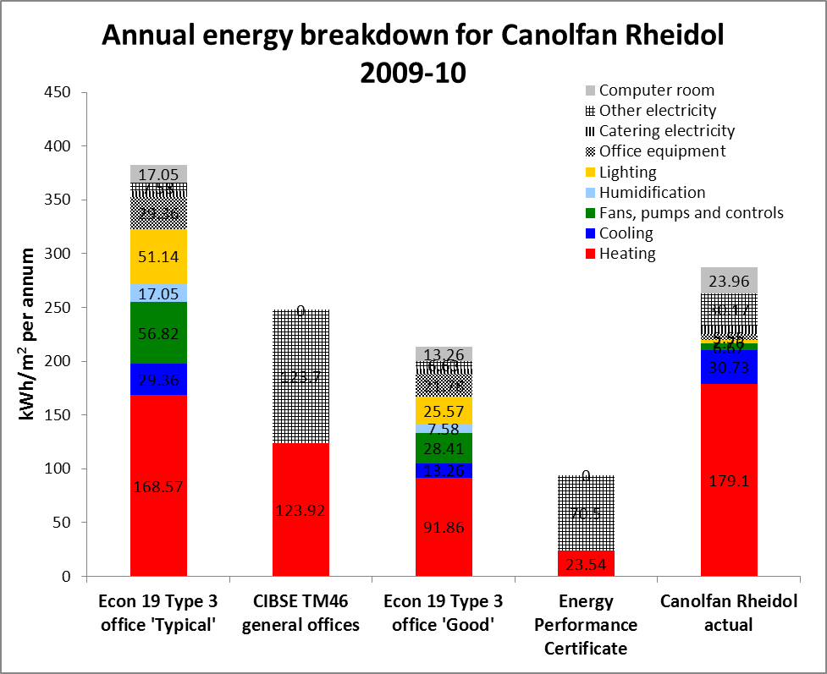

Figure 1: Energy performance of Canolfan Rheidol against the Energy Performance Certificate and relevant benchmarks from Energy Consumption Guide 19 (ECON 19) and CIBSE TM46. High heat consumption is likely due to district heating network losses. Actual lighting consumption is suspected to be inaccurate. Note that these data were current up until the end of Carbon Trust monitoring in 2010.

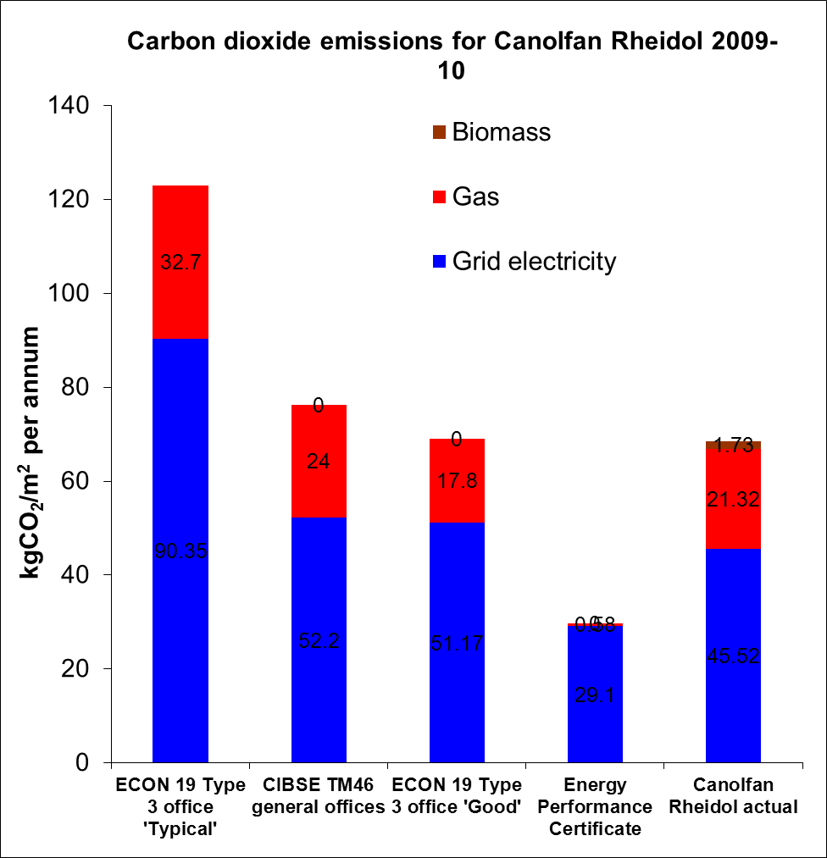

Figure 2: The carbon dioxide emissions for Canolfan Rheidol against the Energy Performance Certificate and relevant benchmarks from Energy Consumption Guide 19 (ECON 19) and CIBSE TM46. The biomass and gas split was not known when the EPC was created. The carbon factors used to calculate emissions were 0.198 for fossil fuel (gas) and 0.423 for electricity.

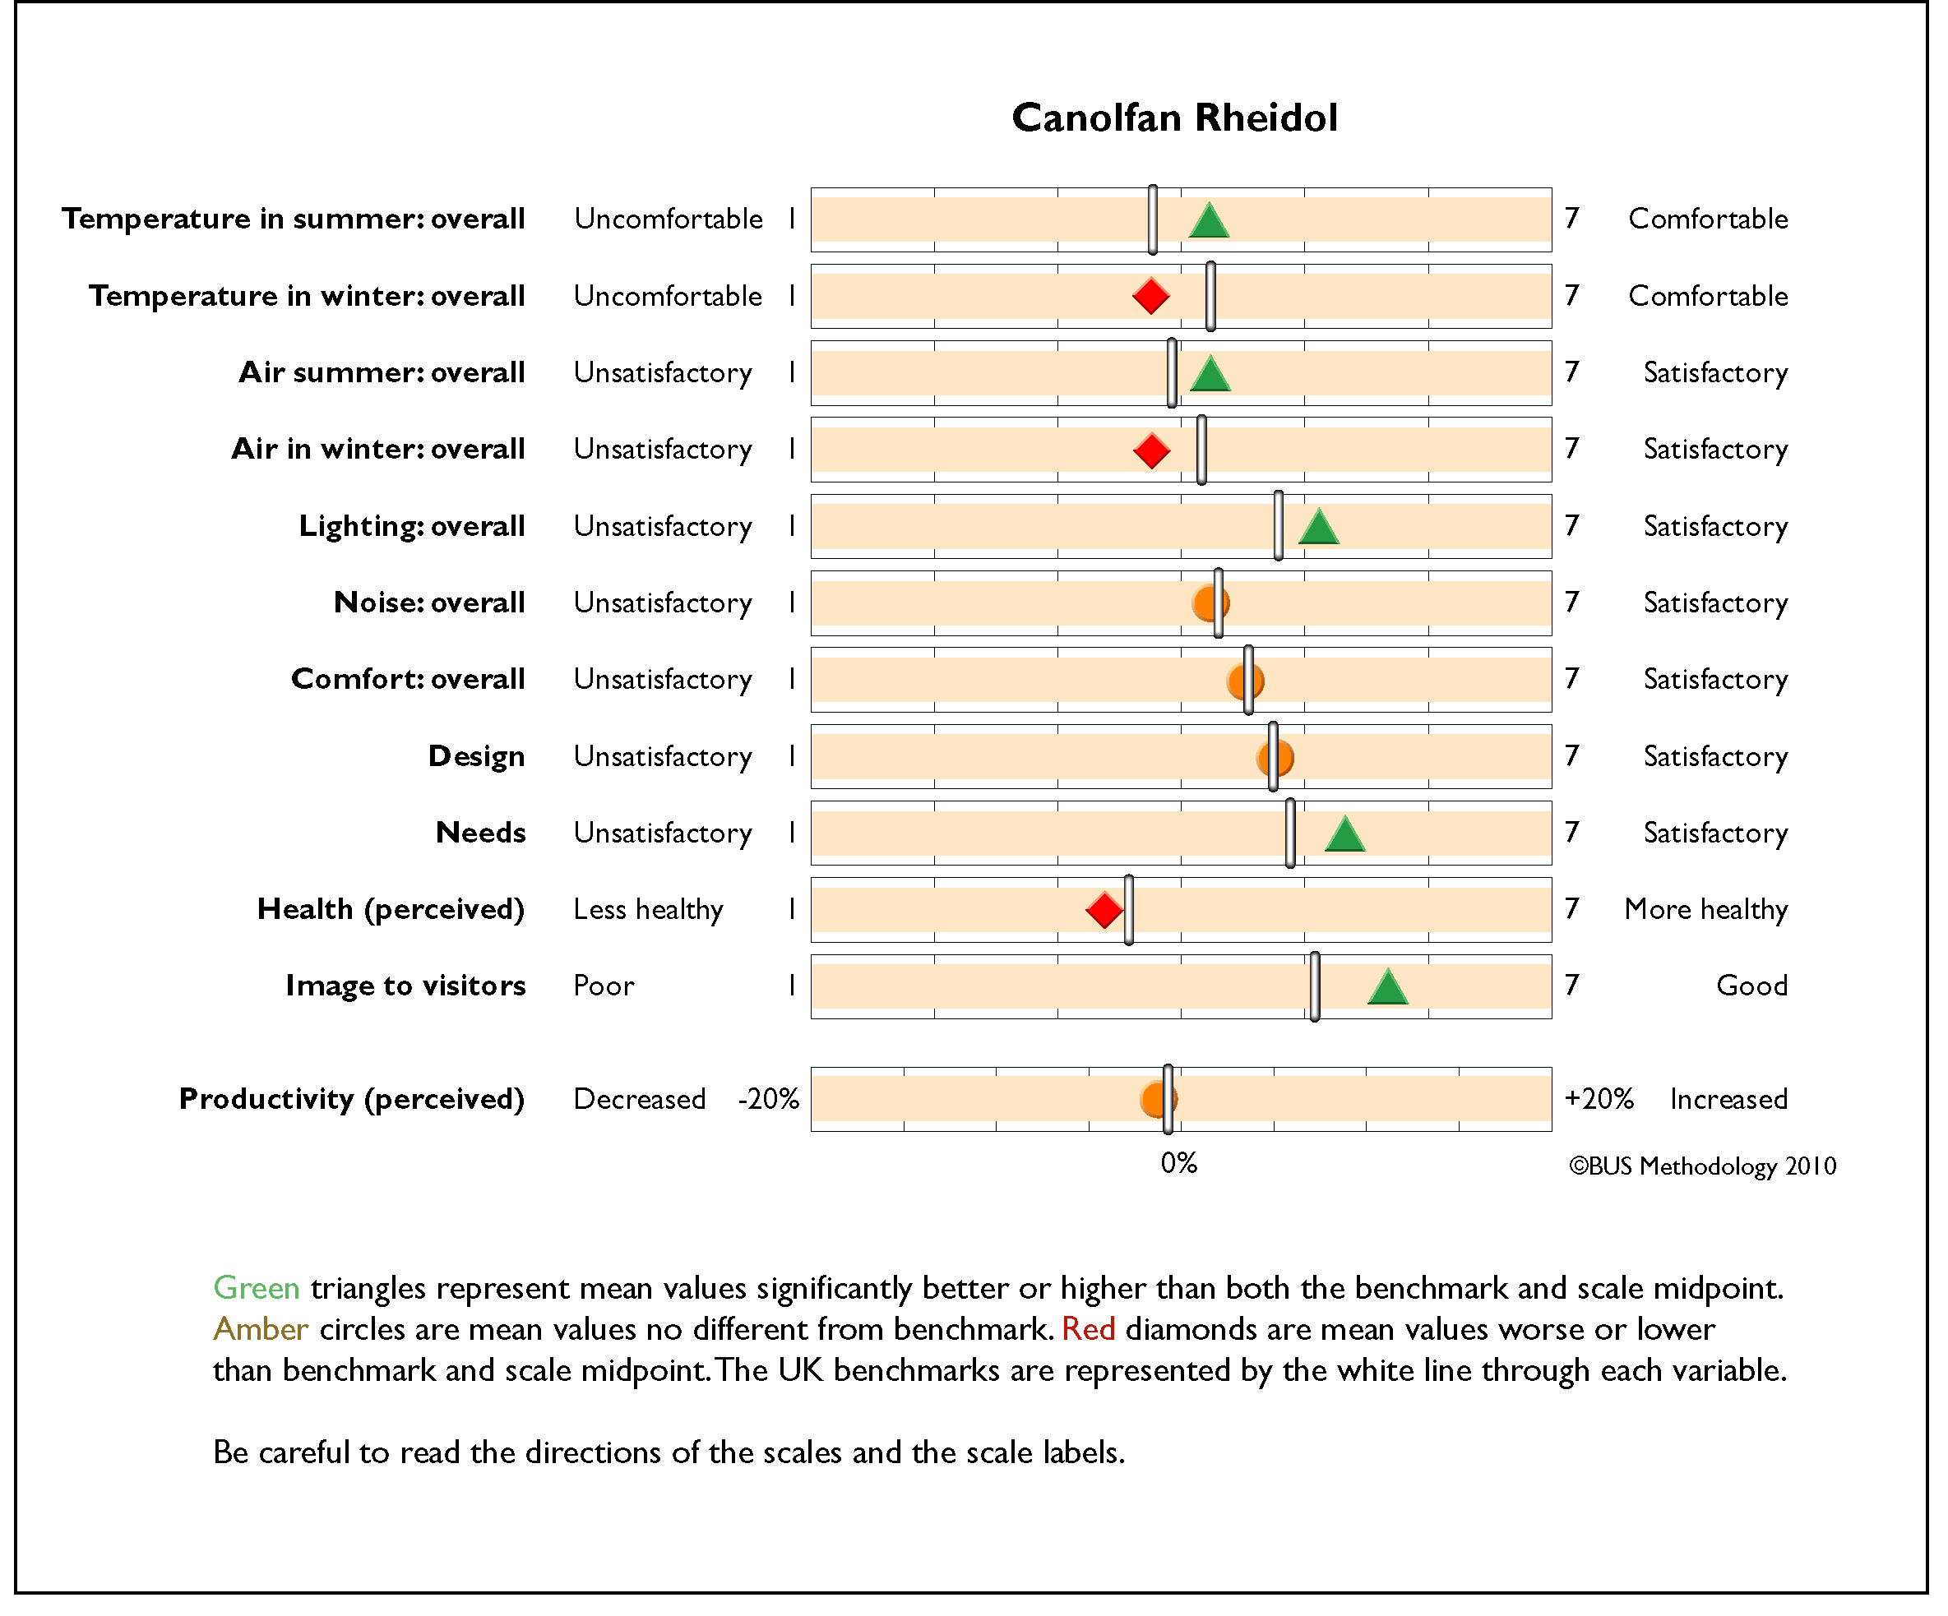

Figure 3: The results of the occupant satisfaction survey. Occupant comfort in Canolfan Rheidol lies between average and good, compared with the UK benchmarks.

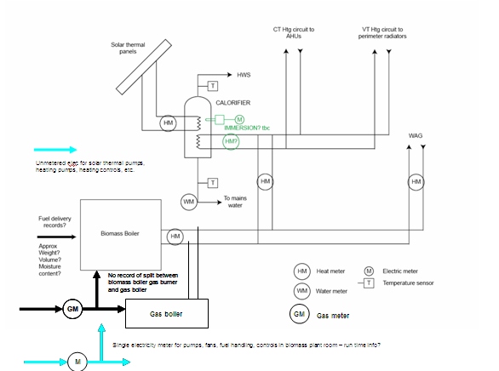

Sketch schematic indicating the metering arrangement for the district heating and solar thermal installations at Canolfan Rheidol.

